**National University of Computer & Emerging Sciences, Karachi**

**Computer Science Department**

**Spring 2022, Lab Manual – 06**

|  |  |
| --- | --- |
| **Course Code: CL-1004** | **Course : Object Oriented Programming Lab** |
| **Instructor(s) :** | **Abeer Gauher, Hajra Ahmed, Syed Zain ul Hassan** |

**LAB - 6**

**Type Casting and Inheritance**

**CASTING**

Type Casting is a feature in Java using which the form or type of a variable or object is cast into some other kind or Object, and the process of conversion from one type to another is called Type Casting.

In Java, there are two types of casting:

Widening Casting (automatically) - converting a smaller type to a larger type size

byte -> short -> char -> int -> long -> float -> double

Narrowing Casting (manually) - converting a larger type to a smaller size type

double -> float -> long -> int -> char -> short -> byte

**Implicit Type Casting**

In **Implicit Type Casting** also known as **Widening Type Casting**, Java automatically converts one data type to another data type.

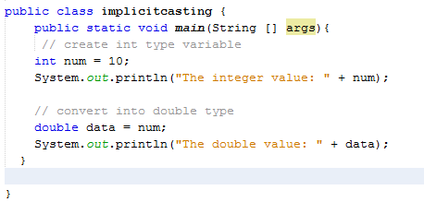Example:



Output:

Java first converts the int type data into the double type. And then assign it to the double variable. The lower data type (having smaller size) is converted into the higher data type (having larger size). Hence there is no loss in data. This is why this type of conversion happens automatically.

**Explicit Type Casting**

In **Explicit Type Casting** also known as **Narrowing Type Casting**, we manually convert one data type into another using the parentheses.

Example:

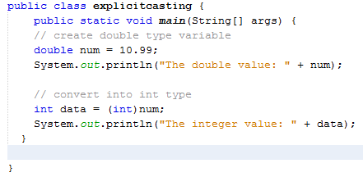

Output:

In the above example, we are assigning the double type variable named num to an int type variable named data.

Notice the line,

**int data = (int)num;**

Here, the int keyword inside the parentheses indicates that that the num variable is converted into the int type.

In the case of Narrowing Type Casting, the higher data types (having larger size) are converted into lower data types (having smaller size). Hence there is the loss of data. This is why this type of conversion does not happen automatically.

**Example: Type conversion from int to String**

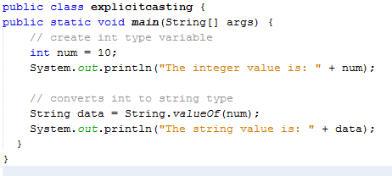

Output:

In the above program, notice the line

**String data = String.valueOf(num);**

Here, we have used the valueOf() method of the Java String class to convert the int type variable into a string.

**Object Casting:**

In Java, the object can also be typecasted like the datatypes. Parent and Child objects are two types of objects. So, there are two types of typecasting possible for an object, i.e., Child to Parent and Parent to Child or can say Upcasting and Downcasting.

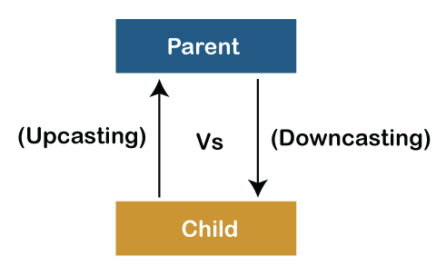

**Upcasting**

Upcasting is a type of object typecasting in which a child object is typecasted to a parent class object. By using the Upcasting, we can easily access the variables and methods of the parent class to the child class. Here, we don't access all the variables and the method. We access only some specified variables and methods of the child class. Upcasting is also known as Generalization and Widening.

Example:

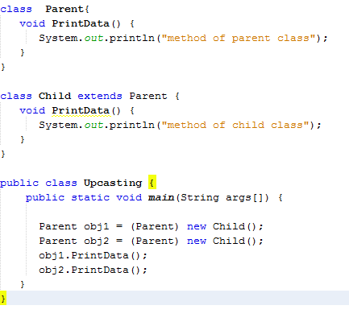

Output:

**Downcasting**

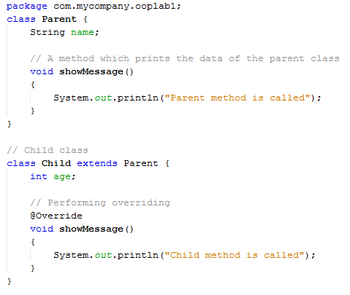In Java, we cannot assign a parent class reference object to the child class, but if we perform downcasting, we will not get any compile-time error. However, when we run it, it throws the "ClassCastException". Now the point is if downcasting is not possible in Java, then why is it allowed by the compiler? In Java, some scenarios allow us to perform downcasting. Here, the subclass object is referred by the parent class.

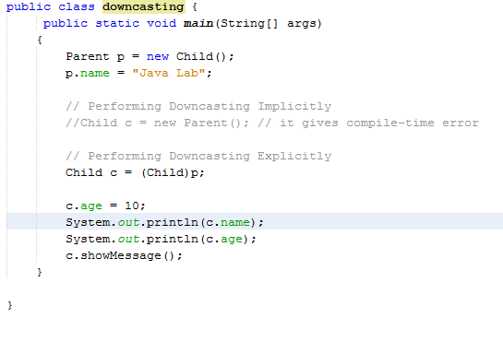

.

**Inheritance:**

Inheritance in Java is a mechanism in which one object acquires all the properties and behaviors of a parent object.

The idea behind inheritance in Java is that you can create new classesthat are built upon existing classes. When you inherit from an existing class, you can reuse methods and fields of the parent class. Moreover, you can add new methods and fields in your current class also.

**Inheritance represents the IS-A relationship which is also known as a parent-child relationship.**

Terms used in Inheritance

* Class: A class is a group of objects which have common properties. It is a template or blueprint from which objects are created.
* Sub Class/Child Class: Subclass is a class which inherits the other class. It is also called a derived class, extended class, or child class.
* Super Class/Parent Class: Superclass is the class from where a subclass inherits the features. It is also called a base class or a parent class.
* Reusability: A mechanism which facilitates you to reuse the fields and methods of the existing class when you create a new class.

The syntax of Java Inheritance

**class Subclass-name extends Superclass-name**

**{**

**//methods and fields**

**}**

The extends keyword indicates that you are making a new class that derives from an existing class.

**Types of inheritance in java**

On the basis of class, there can be three types of inheritance in java: single, multilevel and hierarchical.

In java programming, multiple and hybrid inheritance is supported through interface only.

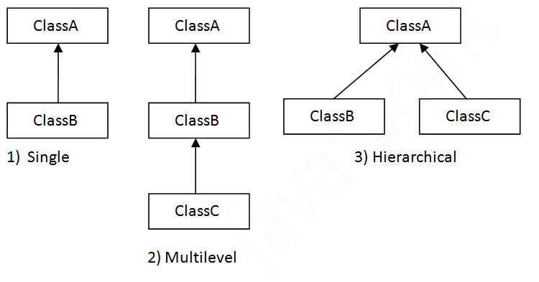

**Single Inheritance Example**

When a class inherits another class, it is known as a single inheritance. In the example given below, Dog class inherits the Animal class, so there is the single inheritance.

**Using super to invoke constructors:**

To explicitly call the superclass constructor from the subclass constructor, we use super(). It's a special form of the super keyword.

super() can be used only inside the subclass constructor and must be the first statement.

The compiler can automatically call the no-arg constructor. However, it cannot call parameterized constructors.

If a parameterized constructor has to be called, we need to explicitly define it in the subclass constructor.

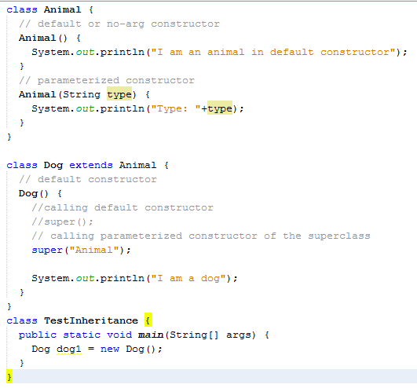



Output:

**Multilevel Inheritance Example**

When there is a chain of inheritance, it is known as multilevel inheritance. As you can see in the example given below, BabyDog class inherits the Dog class which again inherits the Animal class, so there is a multilevel inheritance.

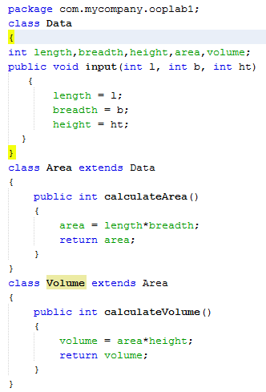

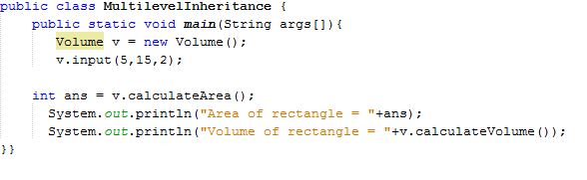

Output:

**LAB#06 EXERCISES**

|  |
| --- |
| **QUESTION#1** Write a Java program that has a class named “Course”.   * The class Course has the attributes course name, course code, class venue and credit hours, all are protected members. * Set all these attributes with a parameterized constructor. * Derive a class “Java Course” that has an attribute teacher name. * Make a constructor and invoke the base class’s parameterized constructor. * Set the teacher name in the constructor. * The derived class has a function Display that displays all the details of the course and the derived class. * In the main, display all the details.   **QUESTION#2** Write a Java program that has a class named “Person”.   * The class has a default constructor that displays “I am a person”. * The class has attributes name, age, nationality, address and CNIC. * The class has an input function that prompts the user to enter all the details. For CNIC, the total number of digits should be exactly 13. If it’s less than 13 or greater display an error message. * The class also has a display function that displays all the details.   Derive a class Employee from Person.   * The class Employee has a default constructor that invokes the base class’s constructor and displays “I am an Employee”. * The class has the attributes name of company, company’s location (city), no of years worked. * The class has an input function that prompts the user to enter all the details. It also has a display function that displays all the details.   Derive a class Manager from Employee.   * The class Manager has a default constructor that invokes the base class’s constructor and displays “I am a Manager”. * The class has an array that contains the names of employee’s who are working under the manager’s supervision. Input atleast five employee’s in the array from the user and display all these employee’s too.   In the main program, call all the functions and display the details.  OOP Exercises - Java Programming Tutorial**QUESTION#3**  Implement the scenario given above in the class diagram.  Display the volume and area in double. Use typecasting and display the volume and area as an integer too.  **QUESTION#4**   * A library wants to organize its system by categorizing books such as Java, C, C++, etc. Implement a program that contains a base class called Books that will contain members such as book ID, book name, book author, ISBN and price. All are protected members. * Derive one class from the base class and name it as “Category1”. * The class has one data member that is the category. * Make a parameterized constructor and invoke the base class’s constructor. * Create a display function and display all the details of the books in Category1 (3 books). * In the main program, perform object up casting and cast child object to a parent class object (Book).   **QUESTION#5**  Implement the scenario given in the figure.    -Speed:int  -Colour: String  -No.of wheels: int  Vehicle  +Speed( )  +Speed(int,string ,int)  +setSpeed(Speed:int): void  +setColour(Colour: String):void  +setWheels(No.of wheels: int): void  +getSpeed( ): int  +getColour(): String  +getWheels(): int  -licenseplate: String  MotorVehicle  +MotorVehicle( )  +set licenseplate (licenseplate: String): void  +getlicenseplate (): String  -no of doors: int  Car  +Car()  +set no of doors(no of doors: int): void  +get no of doors (): int  + display() //display all the details |